**Day 3 Assignment 2:**

Name: Mriganka Patra

Email: mriganka.patra@cognizant.com

Task 1:

| **Field** | **Description** |
| --- | --- |
| **Test Case ID** | TC_SIGNUP_001 |
| **Objective** | Verify user can successfully sign up with valid email and password |
| **Steps** | 1. Navigate to the signup page2. Enter valid email and password3. Click "Sign Up" |
| **Expected Result** | User is successfully registered and redirected to the welcome/dashboard page |

| **Field** | **Description** |
| --- | --- |
| **Test Case ID** | TC_SIGNUP_002 |
| **Objective** | Verify system shows error when email field is left blank |
| **Steps** | 1. Navigate to the signup page2. Leave email field empty3. Enter a valid password4. Click "Sign Up" |
| **Expected Result** | Error message: "Email is required" is displayed, and signup is blocked |

| **Field** | **Description** |
| --- | --- |
| **Test Case ID** | TC_SIGNUP_003 |
| **Objective** | Verify error message is shown for invalid email format |
| **Steps** | 1. Navigate to signup page2. Enter invalid email like user@.com3. Enter valid password4. Click "Sign Up" |
| **Expected Result** | Error: "Invalid email format" is displayed |

| **Field** | **Description** |
| --- | --- |
| **Test Case ID** | TC_SIGNUP_004 |
| **Objective** | Verify error is shown when password field is empty |
| **Steps** | 1. Navigate to signup page2. Enter valid email3. Leave password blank4. Click "Sign Up" |
| **Expected Result** | Error: "Password is required" is displayed |

| **Field** | **Description** |
| --- | --- |
| **Test Case ID** | TC_SIGNUP_005 |
| **Objective** | Ensure that duplicate email signup is blocked |
| **Steps** | 1. Navigate to signup page2. Enter an email that is already registered3. Enter password4. Click "Sign Up" |
| **Expected Result** | Error: "Email already exists" is shown |

Task 2:

| **Test Data ID** | **Email** | **Password** | **Purpose** |
| --- | --- | --- | --- |
| VD001 | user@example.com | Passw0rd! | Standard valid email and password |
| VD002 | john.doe123@mail.co.uk | J0hnDoe@123 | Valid with subdomain and special chars |
| VD003 | test.user+1@gmail.com | Test@2025 | Gmail aliasing, valid special char pwd |
| VD004 | alice_bob99@domain.io | A1iceBob$ | Underscore in email and strong pwd |
| VD005 | new.user@company.tech | MyPass@word1 | Valid TLD and special character usage |

| **Test Data ID** | **Email** | **Password** | **Purpose / Reason for Invalidity** |
| --- | --- | --- | --- |
| ID001 | *(empty)* | StrongPass1! | Missing email |
| ID002 | user@.com | Test1234 | Invalid domain format |
| ID003 | userexample.com | MyPass2025! | Missing @ symbol in email |
| ID004 | user@domain | Pass123 | No domain extension (.com, .net, etc.) |
| ID005 | valid@email.com | *(empty)* | Missing password |
| ID006 | duplicate@site.com | AnotherPass1! | Email already exists (simulate from previous signup) |
| ID007 | user@domain..com | Invalid@123 | Double dots in domain name |
| ID008 | user@domain!.com | ValidPass1 | Invalid character ! in domain |
| ID009 | test@site.com | 123 | Password too short (assume min 6–8 chars) |
| ID010 | test@site.com | password | Password lacks uppercase, number, or special character |

Task 3:

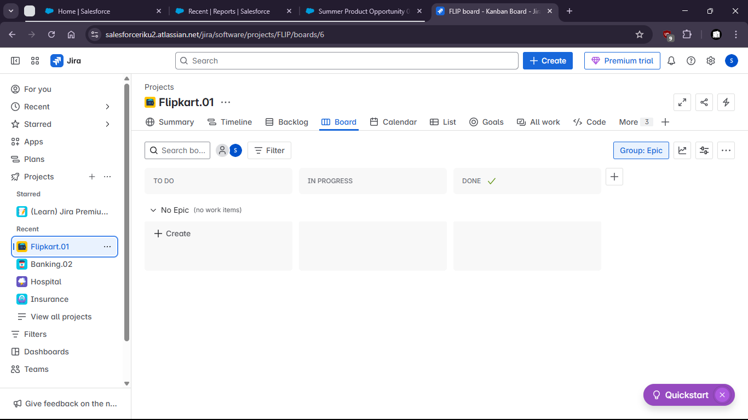

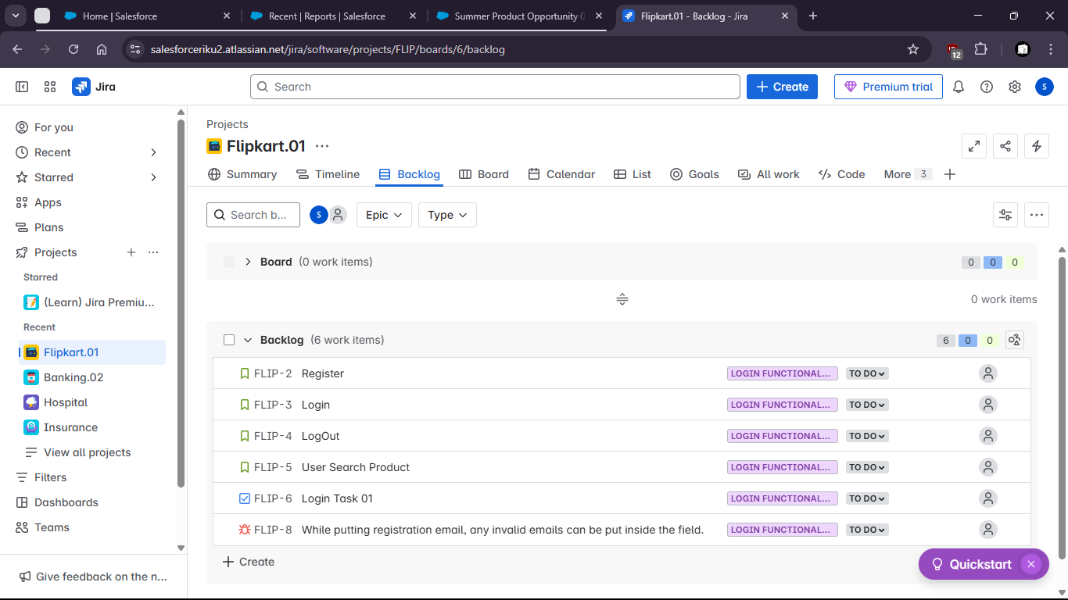

Task 4:

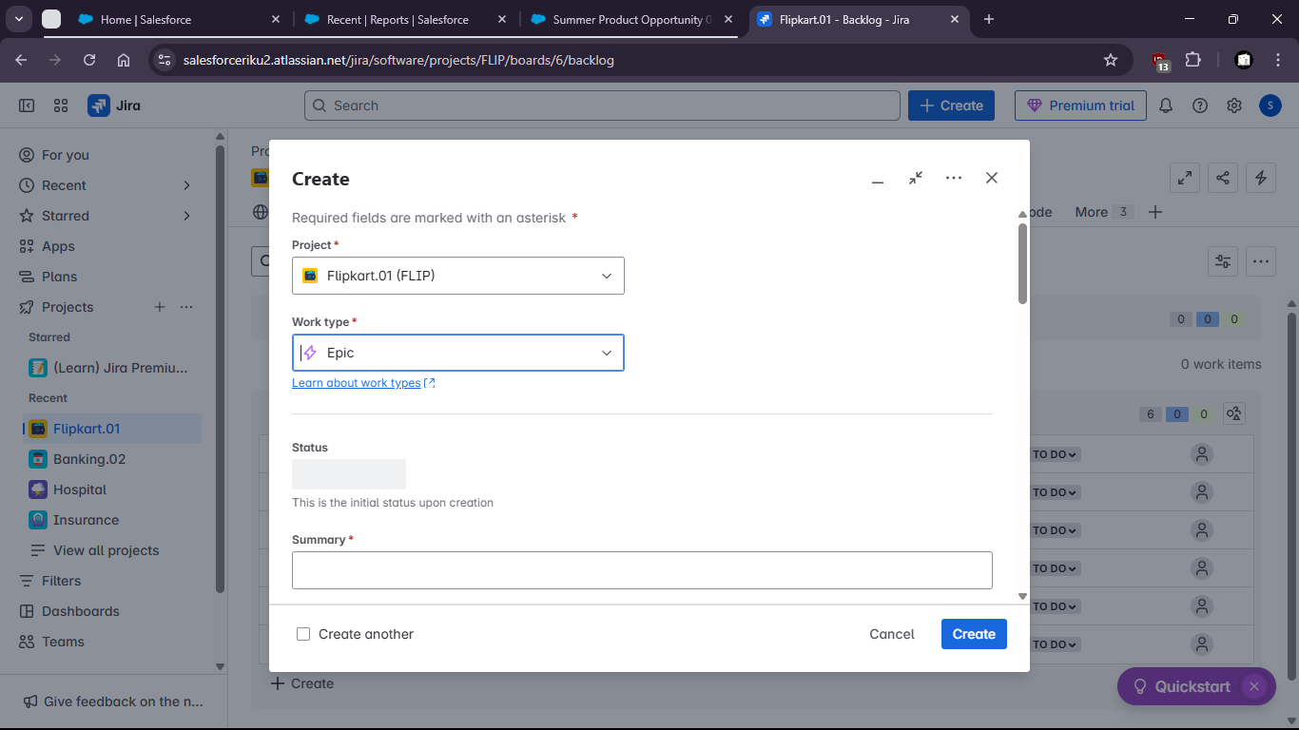

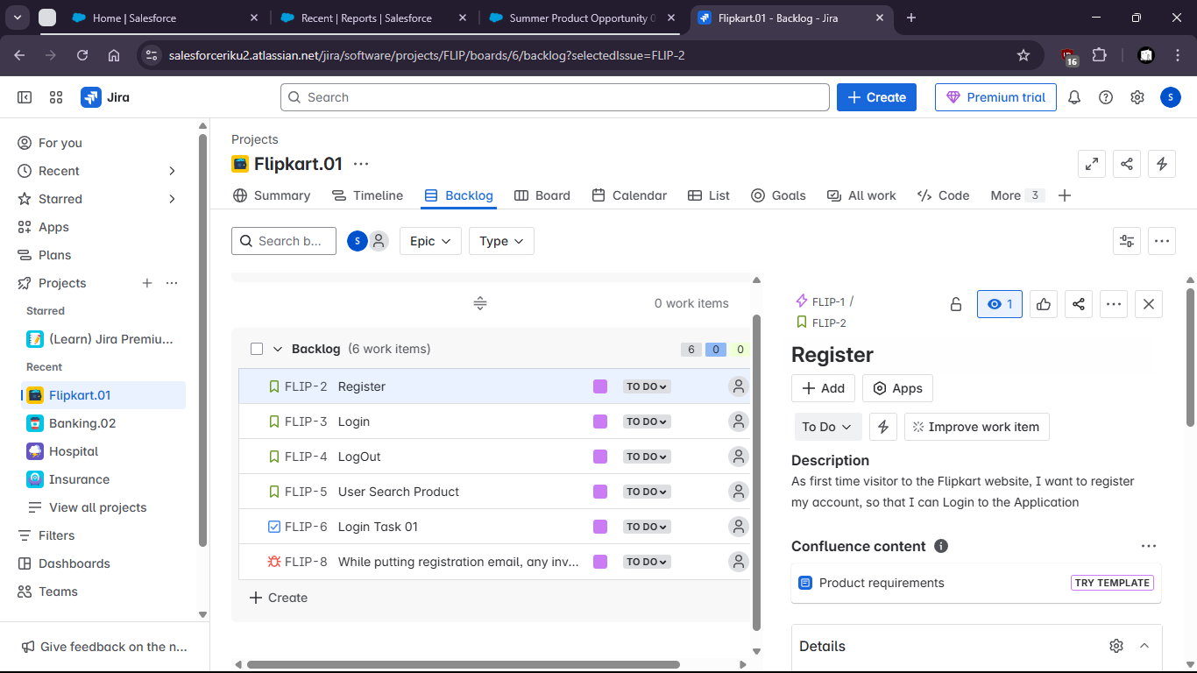

Task 5:

| **Area Covered** | **Status** | **Notes** |
| --- | --- | --- |
| Valid signup (happy path) | Covered | Test case ensures user can register with correct credentials |
| Empty email | Covered | Checks form validation for missing input |
| Invalid email format | Covered | Ensures email syntax is validated |
| Empty password | Covered | Validates password field is mandatory |
| Duplicate email | Covered | Ensures system prevents duplicate registrations |
| Password complexity | Partial | Not explicitly tested for different complexity requirements |
| Email case sensitivity | Missing | Not tested if User@Mail.com and user@mail.com are treated the same |
| Session/login post-signup | Missing | No coverage to check if user is automatically logged in after signup |
| Backend validation or API errors | Missing | No test for server-side error handling or unexpected responses |